Bradbury Lodge
Gordon Woodward Way
Oxford, OX1 4XL
Tel: 01865 725595
www.MyVision.org.uk
info@MyVision.org.uk

Community Engagement Worker (North and West) – Job Description
Our work reaches into the heart of the communities of Oxfordshire, and we’re pleased to be expanding our Community Engagement work into the areas of Cherwell and West Oxfordshire. The key towns in these areas are Banbury, Bicester, Kidlington, Witney, Carterton and Chipping Norton, including surrounding villages. Your role will be to set up peer-to-peer support groups, information days, befriending partnerships, and to be a point of contact for our work in the north and west of the county. Our mission is to support visually impaired people to live independent and active lives and you’ll be playing a key part in this.
We provide a range of services across Oxfordshire including:
- Information & Advice
- Equipment Provision
- Technology Training
- Befriending and Counselling
- Clubs, Groups, and Sporting Activities
- Children’s events
- And much more
You can find out more about our work and services at our website: www.MyVision.org.uk

Job Title: Community Engagement Worker (North and West)
Hours: 35 hours per week
Salary: £23,000 - £28,000 per year dependent on experience
Annual Leave: 25 days per year plus bank holidays (to increase after 3-years)
Contract Type: Permanent (6-month probationary period)
Reporting to: Community Engagement Lead
Start date: Summer 2024
Base: Office/home-based with frequent travel across Cherwell and West Oxfordshire.

Closing Date: Midday 29th April 2024
Interview Date: Wednesday 8th May 2024 (in person at Bradbury Lodge, Oxford)

Job Purpose:
To support visually impaired people to live independent and active lives by providing a range of activities and groups across the north and west of Oxfordshire.

Duties:
- Setting up and supporting peer-to-peer support groups
- Holding information days within local libraries, community centres and other key locations
- Setting up walking groups as part of our Green Walks Project
- Demonstrating and setting up daily living equipment and assistive technology with support from the tech team
- Assisting in the setup of befriending partnerships alongside the Volunteer Coordinator
- Connect, share, and learn with partners and other organisations
- Being a point of contact for MyVision within the North and West of Oxfordshire

Other duties:
- Provide talks and training as needed
- Support the Fundraising team with local events and initiatives
- Keep accurate records of interactions and activites
- Attend relevant meetings, training, workshops, and webinars
- Support the team with furthering the objectives and goals of the organisation
- Other reasonable duties set out by your line manager and Chief Executive
- There may, on occasion, be a need to work outside normal hours e.g., weekends and evenings

Breakdown of duties
This is a rough guide to your duties; flexibility will be required.
Tasks | % of your time
Peer Support Groups and Activities | 40%
Info Days and Equipment Demos | 20%
Befriending Support | 25%
Other duties | 15%

Person Specification

NOTE: We expect candidates to evidence how they meet the criteria in their covering letter. This can be through work, volunteering, and your personal life.
Essential skills, experience, and knowledge:
- Experience of setting up community-based initiatives (for example: groups, clubs, activities etc)
- The ability to research, create and manage working relationships with local groups/organisations across Oxfordshire.
- Good IT skills
- Good communication skills in person, over the telephone and online
- The ability to travel around the county, whether with your own car, public transport or Access to Work support, please see below regarding Access to Work.
- Ideally located within or nearby Cherwell, West Oxfordshire, or Oxford city.

Desirable:
- Lived or learned experience of visual impairment
- Experience of working with visually impaired people
- Experience of providing community-based services for a disability charity

Personal Qualities
- The ability to work under own initiative
- Good communicator
- Creative thinker and problem solving
- A supportive team player
This role may suit someone with lived experience of sight loss, MyVision is a strong advocate of Lived Experience with over half of our employees having a visual impairment. The role would also suit someone who has strong communication skills and the ability to support, encourage and engage people. We also recognise many skills are transferrable and welcome applications from people with varying experiences and backgrounds.

Safeguarding
MyVision is committed to safeguarding children and vulnerable adults. You can find our safeguarding policy here – Safeguarding Policy. This role is subject to a DBS check and two references.

Equal Opportunities and Disability
MyVision is an equal opportunities employer and Disability Confident Leader. If you have any concerns about the role or the application process that may relate to your disability or health condition, please do contact us. We are also a Youth Friendly Employer and signed up to the Mental Health at Work Commitment.
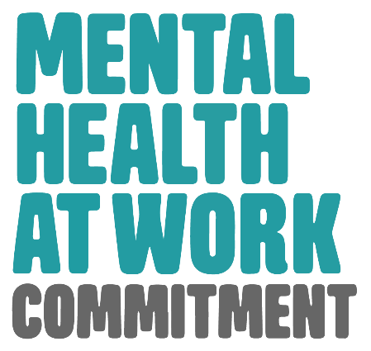
MyVision has a strong commitment to employing staff and volunteers with lived experience of sight loss, you can find out more here: MyVision Oxfordshire Commitment to Lived Experience.

Access to Work
Support can be provided through Access to Work if you have a disability or long-term health condition. This can be equipment, travel to work, or travel within work. You can find out more about Access to Work here: Access to Work.

How to apply
Please send an up-to-date copy of your CV, including two references and a covering letter (no more than 500 words) evidencing how your skills and experiences meet the persons specifications and job role. You may use evidence from work, volunteering, and your personal life. Please use no more than 500 words. You can send your CV and covering letter to recruitment@MyVision.org.uk. If you have any questions, please don’t hesitate to contact us.
The closing date is: Midday 29th April 2024

