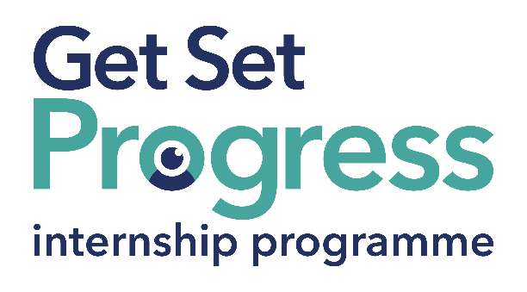

Fundraising Assistant

Join us at MyVision Oxfordshire
Thomas Pocklington Trust (TPT) and RNIB are collaborating with charities in the sight loss sector to create new opportunities for blind and partially sighted people to find employment through the Get Set Progress Internship programme. This post has a Genuine Occupational Requirement that the successful applicant be a person who is blind or partially sighted, in line with The Equality Act 2010. MyVision Oxfordshire is delighted to be offering an internship as part of the Get Set Progress scheme.

MyVision Oxfordshire offers free information, advice, and support to blind and visually impaired adults and children in Oxfordshire.

Sight loss is a challenging reality for thousands of people in our local community and we are committed to supporting visually impaired people achieve independence and confidence. MyVision Oxfordshire provides a range of services across the county including:
- Information & Advice
- Equipment Provision
- Technology Training
- Befriending and Counselling
- Clubs, Groups, and Sporting Activities
- Children’s events
- And much more
You can find out more about our work and services at our website: www.MyVision.org.uk

Our Values
MyVision is committed to supporting visually impaired people to achieve independence and confidence.
MyVision has a strong commitment to employing staff and volunteers with lived experience of sight loss.

What are the benefits of a Get Set Progress internship for me?
As part of your 9-month internship, you will gain the following:
- Obtain valuable work experience within the charity sector
- Training opportunities
- A personal mentor offering support, advice and guidance throughout your internship
- Help deliver positive changes for people with sight loss

As part of the GSP Internship programme, you will also be enrolled on the TPT Employment Programme, where you will gain employment support, guidance and advice from the TPT Employment Team, some of the obtainable skills are:
- CV writing
- Job searching
- Cover letter and speculative letter writing
- Application form writing
- Interview techniques
Job description

Role: Fundraising Assistant
Department: Fundraising
Reporting to: Fundraising Manager
Location: Office/home-based (Oxford) with some home working.
Salary: £11.35 per hour based on the Oxford Living Wage. (Annually this is £20,657)
Contract type: Fixed Term 9 months, full time 35 hours per week

Job Specification Information

Job purpose: Overview of the role:
To provide support to the fundraising team, with a particular focus on donor relationships and community fundraising. This role will sit within the busy fundraising team providing both administration support and a regular connection to our supporters and donors within the community.

Key areas of responsibility:
1. Fundraising administration support
- Supporting day to day admin within the fundraising team
- Writing small grant applications
- Helping research new income streams
- Supporting the development of fundraising knowledge within the team
- Ensure all donor data is kept up-to-date
- Record all relevant interactions with donors and supporters
- Provide reports for the team on donations and supporter data

2. Donor relationships
- Regularly contacting donors to offer thanks and information about where the donation has gone
- Building strong relationships with regular donors
- Developing our donor relationship programme
3. Community Fundraising
- Supporting the Community Fundraising Group
- Working with the team to provide small events and fundraising activities throughout the county
- Developing a range of our community fundraising activities across the county, this may include: collection tins, community events etc
- Supporting and encouraging uptake of various challenge events throughout the year
4. Other duties
- Attend and contribute to team meetings
- Attend relevant training and networking events
- Be an ambassador for MyVision and help us to reach out, grow and continue to support visually impaired people across Oxfordshire
- Other reasonable duties set out by your line manager and Chief Executive
- There may, on occasion, be a need to work outside normal hours e.g., weekends and evenings

Personal Specification - Essential criteria:
Lived experience of sight loss
Strong communication skills
Strong organisational skills
Good computer literacy

What to do next
Please send an up-to-date copy of your CV, including two references. We also require a covering letter evidencing how your skills and experiences meet the persons specifications and job role. You may use evidence from work, volunteering, and your personal life. Please use no more than 500 words.
You can send your CV and covering letter to recruitment@MyVision.org.uk. If you have any questions, please don’t hesitate to contact us.

Closing date:
17:00 on 13/11/2023

About MyVision Oxfordshire

Safeguarding
MyVision is committed to safeguarding children and vulnerable adults. You can find our safeguarding policy here – Safeguarding Policy. This role is subject to a DBS check and two references.

Equal Opportunities and Disability
MyVision is an equal opportunities employer and Disability Confident Leader. If you have any concerns about the role or the application process that may relate to your disability or health condition, please do contact us. We are also a Youth Friendly Employer, and signed up to the Mental Health at Work Commitment.
MyVision has a strong commitment to employing staff and volunteers with lived experience of sight loss, you can find out more here: MyVision Oxfordshire Commitment to Lived Experience.

Access to Work
Support can be provided through Access to Work if you have a disability or long-term health condition. This can be equipment, travel to work, or travel within work. You can find out more about Access to Work here: Access to Work.

